Ulnar nerve
- Also called musician’s nerve
- “Ulnar” in position in forearm
- Supplies most of the intrinsic muscles of hand
- Responsible for many fine movements of hand
- Largest unprotected (meaning not protected by muscle or bone) nerve in the body
- Injury causes clawing

Humorous!
Irritation of this nerve is commonly referred to as hitting one's "funny bone."
This name is thought to be a (conscious or subconscious) pun, based on the sound resemblance between words "humerus" and "humorous"

Palpable nerves
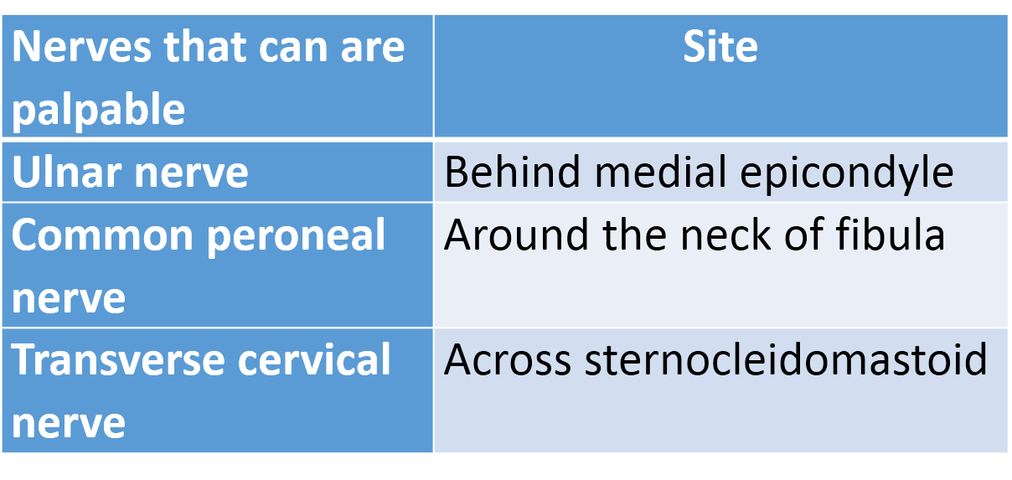

Root value
C7,8 and T1
- C8 and T1 fibres pass through medial cord
- Ulnar nerve also receives C7 fibres

Formation
Branch of medial cord of brachial plexus

Course
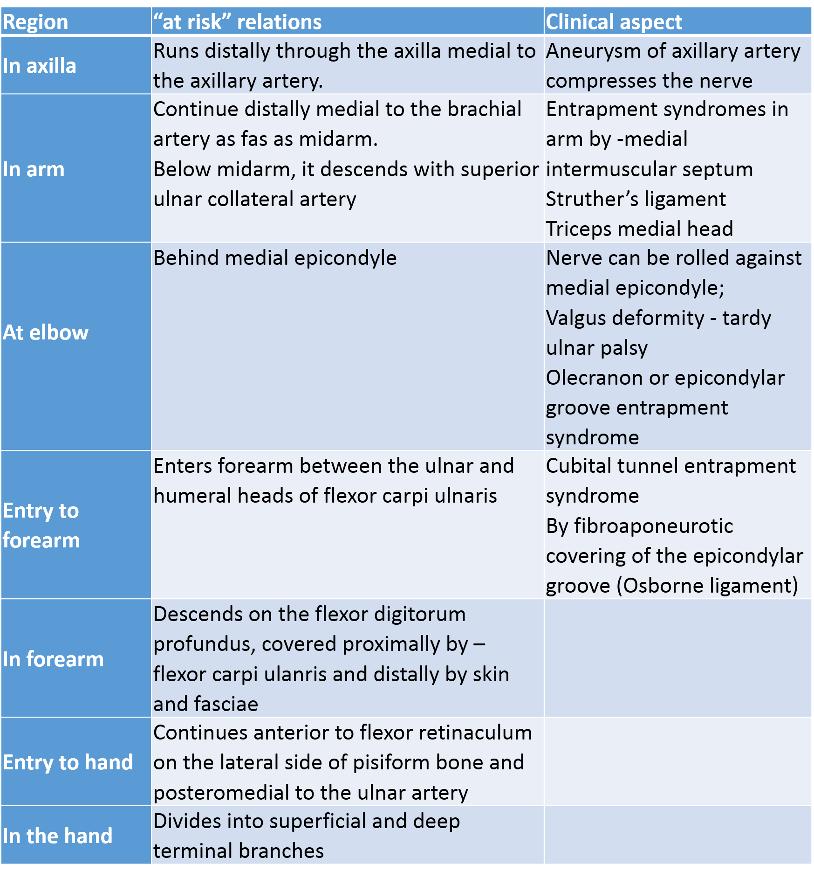
[TIP]Watch the video
[YOUTUBE] https://youtu.be/mGeuAklTCcc
Branches
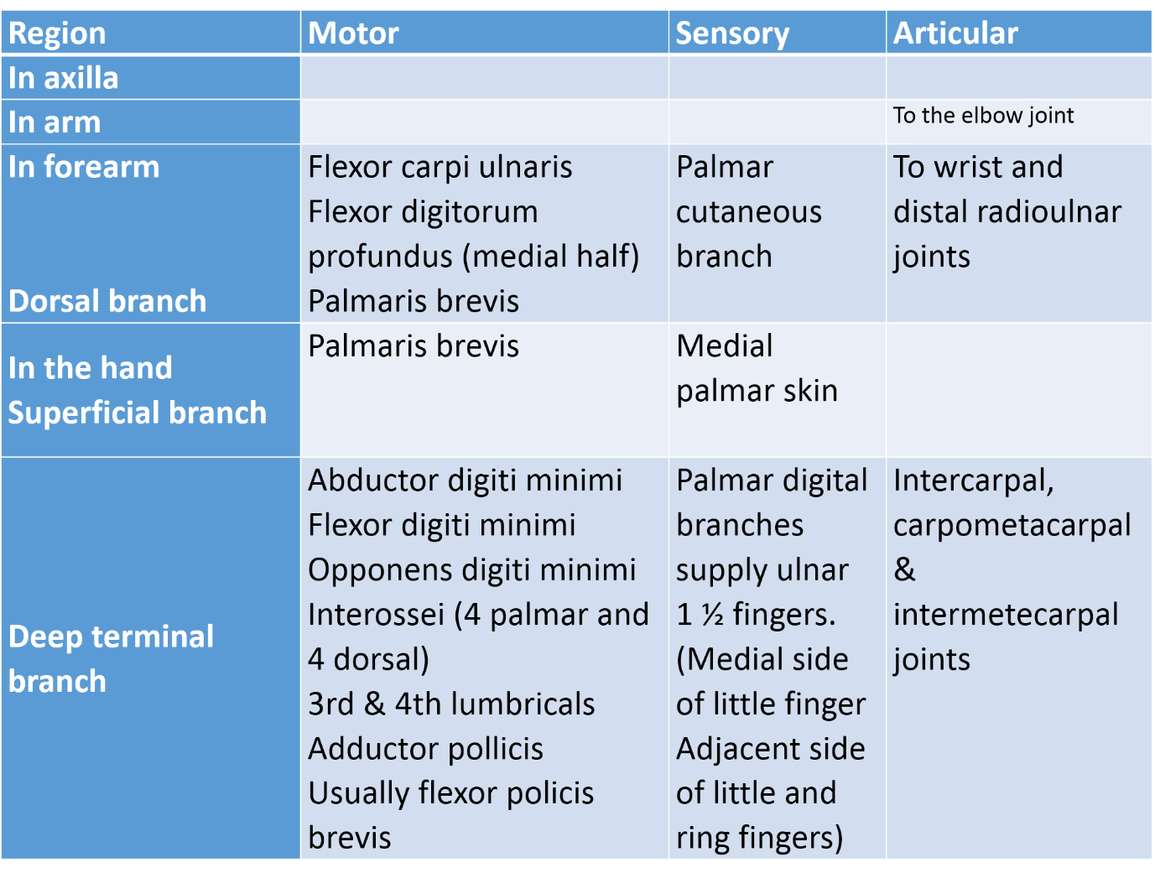
[TIP]Watch and learbn
[YOUTUBE] https://youtu.be/0fbfDp762vk

Palmar cutaneous branch of ulnar nerve
- Arises about midforearm, descends on ulnar artery.
- Perforates deep fascia to end in palmar skin
- Communicates with palmar branch of median nerve.

Dorsal branch
- Sometimes supplies palmaris brevis.
- Arises about 5 cm proximal to wrist.
- Passes down, deep to flexor carpi ulnaris, perforates deep fascia, descends along medial side of back of wrist and hand
- Divides into dorsal digital nerves - 2, sometimes 3.

Superficial terminal branch
- Supplies
  - Palmaris brevis.
  - Medial palmar skin.
- Divides into 2 palmar digital nerves
- Can be palpated against hook of hamate bone.
- Supplies medial side of little finger
- Common palmar digital nerve – sends twigs to median nerve
- Divides into 2 proper digital nerves for adjoining sides of little and ring fingers.

Deep terminal branch
- Passes with deep branch of ulnar artery
- Between abductor digiti minimi and flexor digiti minimi
- Perforates the opponens digiti minimi
- Dorsal to flexor tendon – follow deep palmar arch
- Supply
  - Abductor digiti minimi
  - Flexor digiti minimi
  - Opponens digiti minimi
  - Interossei
  - 3rd & 4th lumbricals
  - Adductor pollicis
  - Usually flexor policis brevis.
  - Joints
    - Intercarpal, carpometacarpal & intermetecarpal joints

Tests for ulnar nerve
1. Froment’s sign: patient holds the book between thumb and index fingers against resistance. Three muscles are tested – first palmar interossei, adductor pollicis and flexor pollicis longus.
In case of ulnar nerve injury – flexor pollicis longus is used predominantly resulting in flexion of thumb.
2. Card test: patient holds a card against resistance between the fingers.
In case of ulnar nerve injury, card can not be held due to lack of power by interossei.

Applied aspects
The most common sites of entrapment around the elbow are the
- Olecranon groove
- Cubital tunnel

Ulnar nerve injury
- Ulnar nerve lacerations are commonly referred to as high or low to reflect whether the injury affects extrinsic and intrinsic muscles.
- High ulnar nerve injury
  - Paralysis of the flexor carpi ulnaris
  - Ulnar half of the flexor flexor digitorum profundus
  - The distal phalanges of the fourth and fifth fingers cannot flex.
  - Some weak flexion of the fourth and fifth fingers may be possible as motor units have a common origin.
  - Paralysis of the flexor carpi ulnaris
  - An attempt to flex the wrist results in radial deviation

Claw hand
- The MCP joints are hyperextended, and the IP joints are flexed. These changes are more obvious at the ring and little fingers, because the first and second lumbrical muscles are not paralyzed.
- The thumb can weakly adduct through the extensor pollicis longus
- Froment sign - during pinching.
- Loss of the ulnar-innervated adductor pollicis results in reliance on the flexor pollicis longus and exaggerated interphalangeal joint flexion.
- Loss of the metacarpophalangeal joint flexor leads to MCP hyperextension over time

Ulnar paradox
The ulnar claw deformity is more pronounced for lesions distally as compared to a more proximal lesion
This is because – in higher lesions, the long flexors are paralysed. The loss of finger flexion makes the deformity look less obvious.
A more proximal lesion at the elbow also causes weakness of the ulnar half of the flexor digitorum profundus, resulting in less flexion of the interphalangeal joints of the 4th and 5th fingers.

Cutaneous innervation of ulnar nerve
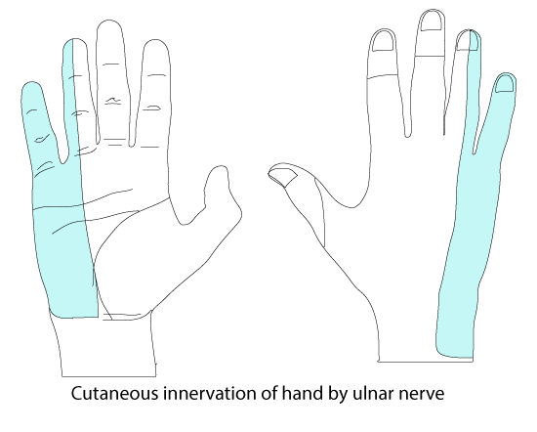
Autonomous zone of ulnar nerve is little finger
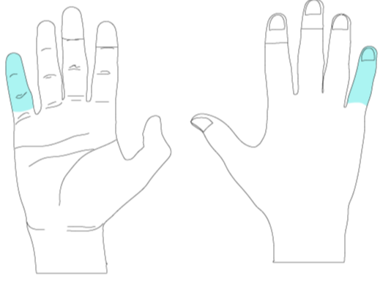

Guyon canal
Is an oblique fibro-osseous tunnel that lays within the proximal part of the hypothenar eminence;
It is confined by the
- Pisiform
- Hook of the hamate
Covered
- Proximally by the palmar carpal ligament
- Distally by the short palmar muscle
- Contains -ulnar nerve, ulnar artery with their venae comitantes and loose fibrofatty tissue.
- Within the canal, ulnar nerve divides into superficial sensory and deep motor branches
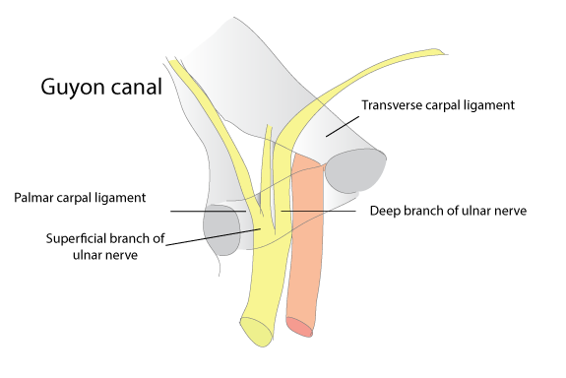
___MCQ_START___
Q1. The ulnar nerve enters the hand by passing:
A. Deep to flexor retinaculum
B. Through carpal tunnel
C. Through Guyon’s canal[CORRECT]
D. Through anatomical snuffbox
___
Q2. All the following structures pass superficial to the flexor retinaculum EXCEPT:
A. Ulnar nerve
B. Ulnar artery
C. Palmar cutaneous branch of ulnar nerve
D. Median nerve[CORRECT]
___
Q3. Froment’s sign becomes positive due to paralysis of which muscle?
A. Opponens pollicis
B. Adductor pollicis[CORRECT]
C. Abductor pollicis brevis
D. Flexor pollicis longus
___
Q4. The classical “ulnar claw hand” is most marked in injury at which level?
A. Above elbow
B. At medial epicondyle
C. At wrist[CORRECT]
D. In axilla
___
Q5. Loss of abduction and adduction of fingers in ulnar nerve injury is due to paralysis of:
A. Lumbricals
B. Thenar muscles
C. Interossei muscles[CORRECT]
D. Flexor digitorum superficialis
___
Q6. Sensory loss in ulnar nerve injury at the wrist involves:
A. Lateral three and a half digits
B. Medial one and a half digits[CORRECT]
C. Only the little finger
D. Entire palm
___
___MCQ_END___

